

TRIBHUVAN UNIVERSITY

INSTITUTE OF ENGINEERING

PURWANCHAL CAMPUS

A

LAB REPORT

ON

“**Implementation of Banker’s Algorithm for avoiding Deadlock**”

**Submitted By**:

SOHEL AKHTAR (075 BCT 081)

**Submitted To**:

PUKAR KARKI

**DEPARTMENT OF**

**ELECTRONICS AND COMPUTER ENGINEERING**

**DHARAN, NEPAL**

**Lab 3: Implementation of Banker’s Algorithm for avoiding Deadlock**

**Theory:** The Banker’s algorithm, developed by Edsger Dijkstra, is a resource allocation and deadlock avoidance algorithm.

When a new process enters a system, it must declare the maximum number of instances of each resource type that it may ever claim; clearly, that number may not exceed the total number of resources in the system. Also, when a process gets all its requested resources it must return them in a finite amount of time.

For the Banker's algorithm to work, it needs to know three things:

• How much of each resource each process could possibly request ("MAX")

• How much of each resource each process is currently holding ("ALLOCATED")

• How much of each resource the system currently has available ("AVAILABLE")

Resources may be allocated to a process only if the amount of resources requested is less than or equal to the amount available; otherwise, the process waits until resources are available. Let **n** be the number of processes in the system and **m** be the number of resource types. Then we need the following data structures:

• **Available:**  A vector of length m indicates the number of available resources of each type. If Available[j] = k, there are k instances of resource type Rj available.

• **Max:** An n x m matrix defines the maximum demand of each process. If Max[i, j] = k, then Pi may request at most k instances of resource type Rj.

• **Allocation:** An n x m matrix defines the number of resources of each type currently allocated to each process. If Allocation[i, j] = k, then process Pi is currently allocated k instances of resource type Rj.

• **Need:** An n x m matrix indicates the remaining resource need of each process. If Need[i, j] = k, then Pi may need k more instances of resource type Rj to complete the task.

Also, **Need[i, j] = Max[i, j] – Allocation[i, j]**

**Idea:**

1. There are two vectors **copyAvailable** and **finished** of length m and n in a safety algorithm. **Initialization**

copyAvailable = available

finished[i] = false; for i = 0, 1, 2, 3, 4… n-1. 2.

2. Check the availability status for each process i for each type of resources j, such as:

need[i][j] <= copyAvailable[j]

finished[i] == false

If the j does not exist, go to step 4.

3. Set,

newAvailable[j] = newAvailable[j] +allocation[i][j]

finished[i] = true

Go to step 2 to check the status of resource availability for the next process.

4. If finished[i] == true; it means that the system is safe for all processes.

**Note:** The Banker's algorithm has some limitations when implemented. Specifically, it needs to know how much of each resource a process could possibly request. In most systems, this information is unavailable, making it impossible to implement the Banker's algorithm. Also, it is unrealistic to assume that the number of processes is static since in most systems the number of processes varies dynamically. Moreover, the requirement that a process will eventually release all its resources (when the process terminates) is sufficient for the correctness of the algorithm, however it is not sufficient for a practical system. Waiting for hours (or even days) for resources to be released is usually not acceptable.

**Source Code**

#include <iostream>

#include <cstdlib>

#define n 5

#define m 3

using namespace std;

void computeNeed(int need[n][m], int maximum[n][m], int allocated[n][m]);

bool isSystemSafe(int process[n], int available[m],

                  int maximum[n][m], int allocated[n][m]);

int main()

{

    // Total number of processes

    int process[n] = {0, 1, 2, 3, 4};

    // Available units of resources

    int available[m] = {3, 3, 2};

    // Maximum units of resources that can be allocated to processes

    int maximum[n][m] = {{7, 5, 3},

                         {3, 2, 2},

                         {9, 0, 2},

                         {2, 2, 2},

                         {4, 3, 3}};

    // Resources currently allocated to processes

    int allocated[n][m] = {{0, 1, 0},

                           {2, 0, 0},

                           {3, 0, 2},

                           {2, 1, 1},

                           {0, 0, 2}};

    // Check whether the system is in safe state or not

    isSystemSafe(process, available, maximum, allocated);

    return 0;

}

void computeNeed(int need[n][m], int maximum[n][m], int allocated[n][m])

{

    for (int i = 0; i < n; i++)

        for (int j = 0; j < m; j++)

            need[i][j] = maximum[i][j] - allocated[i][j];

}

bool isSystemSafe(int process[n], int available[m],

                  int maximum[n][m], int allocated[n][m])

{

    int i, j, k;

    bool flag;

    int need[n][m];

    // First we compute need

    computeNeed(need, maximum, allocated);

    // Initially all processes are marked as unfinished

    bool finished[n] = {false};

    // Array to store the safe sequence of execution

    int safeSequence[n];

    // Since we will be mutating available

    // array, we make its copy and work on that copy

    int copyAvailable[m];

    for (i = 0; i < m; i++)

        copyAvailable[i] = available[i];

    int count = 0;

    while (count < n)

    {

        // Find a process which is unfinished and whose need can be

        // satisfied from current available resources

        flag = false;

        for (i = 0; i < n; i++)

        {

            if (!finished[i])

            {

                // Check if all of the process need

                // is less than available

                for (j = 0; j < m; j++)

                    if (need[i][j] > copyAvailable[j])

                        break;

                // If all of the process need are less

                // than what is avalable

                if (j == m)

                {

                    // This means that the process can finish its execution and

// when it finishes then we can free the resources it was

// using

                    for (k = 0; k < m; k++)

                        copyAvailable[k] += allocated[i][k];

                    // This process can be executed safely

                    safeSequence[count++] = i;

                    // This process is finished

                    finished[i] = true;

                    flag = true;

                }

            }

        }

        if (flag == false)

        {

            cout << "System is not in safe state " << endl;

            return false;

        }

    }

    cout << "System is in safe state.\nSafe sequence is: ";

    for (int i = 0; i < n; i++)

        cout << safeSequence[i] << "\t";

    return true;

}

**Output**

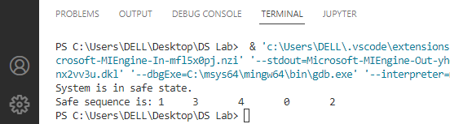

**Analysis:**

Here, we have found the safe sequence for the following.

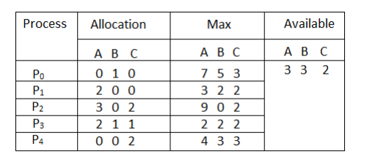

**Conclusion:** Hence, in this lab, we successfully implemented the Banker’s Algorithm for avoiding the deadlock.